

**Postman API Testing**

**Assignment 01**

**Prepared by:**

Basirat Zahra

10Pearls QA Shine Intern

**Prepared for:**

10Pearls QA Training Team

**Submission Date:**

April 29, 2025

**Assignment No. 1: Postman**

Create Postman collections using any one of given testing APIs sources and make sure following points are covered in them, you are required to use all of API methods (GET, PUT, POST, PATCH, DELETE) at least once for the following:

1. **Set Base URL as a variable and use it for all API methods**

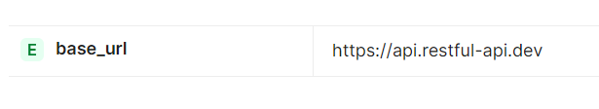

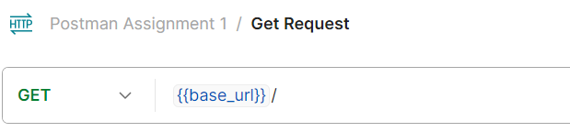

**Response:**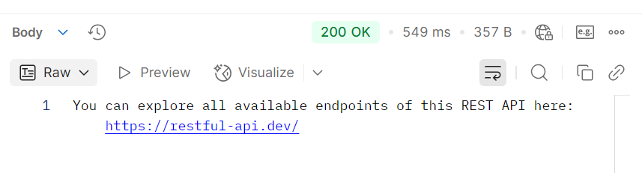

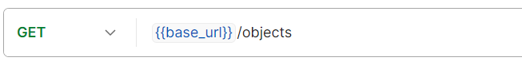

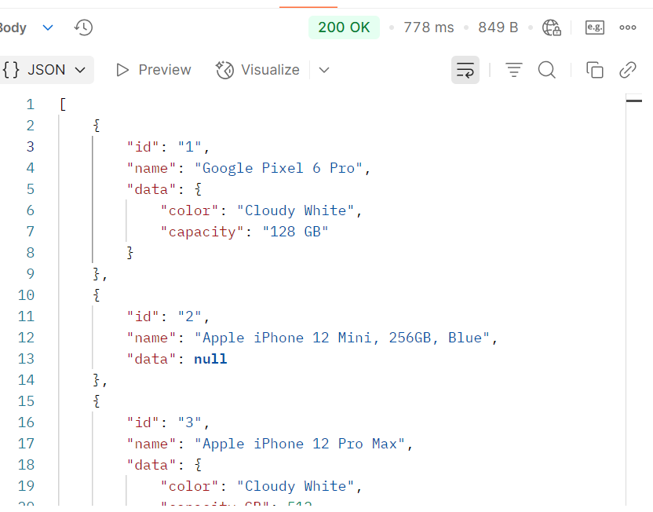

1. **Generate Random data to be used in API request body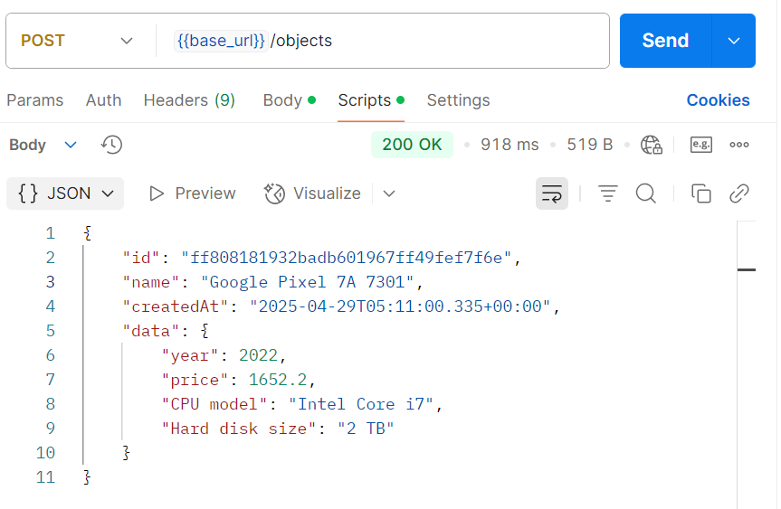 Script:**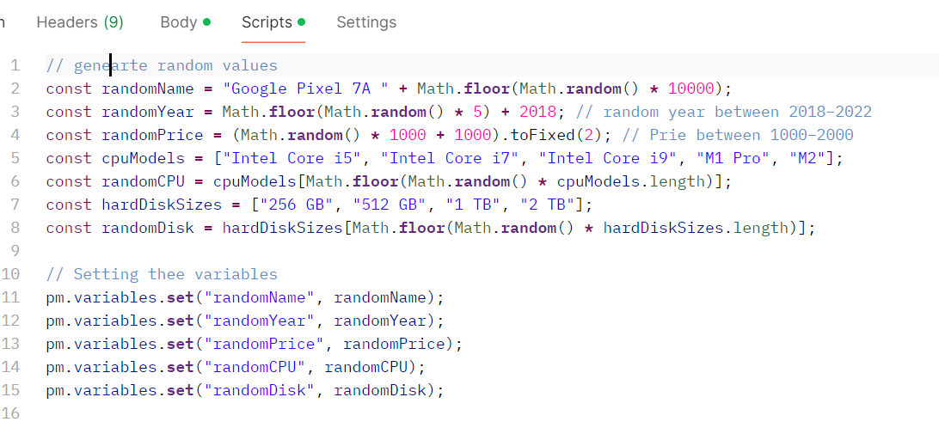

**Request Body:**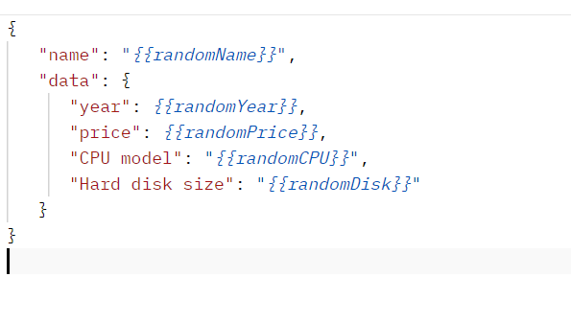

1. **Parse the JSON response body and log the value of any property in Postman Console**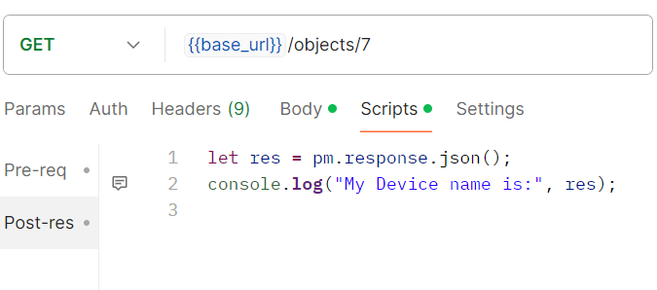

**Console output:**

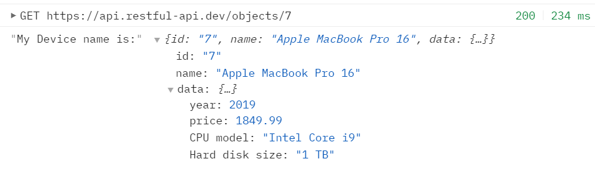

1. **Use Postman Chai Assertion Library to verify values in response data.**

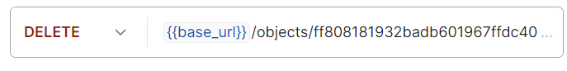

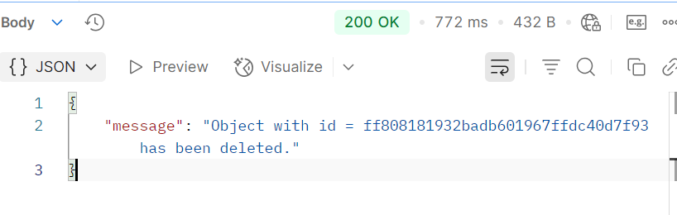

**Test Result:**

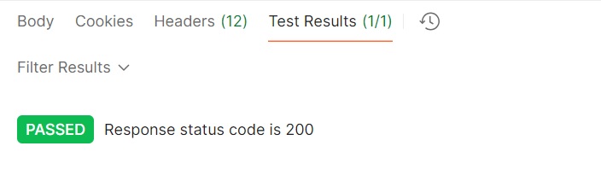

1. **Write a Postman assertion to deliberately fail a test case.**

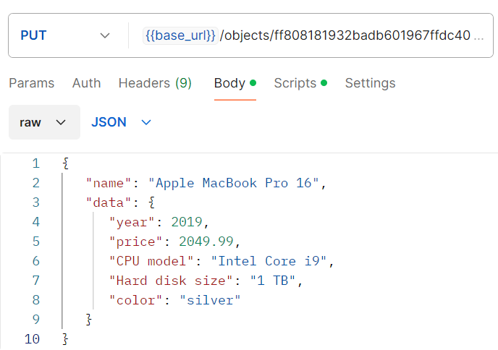

**Response:**

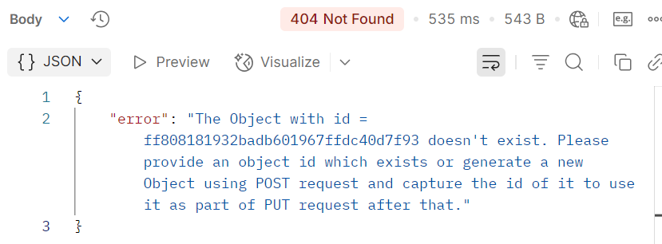

**Test Result:**

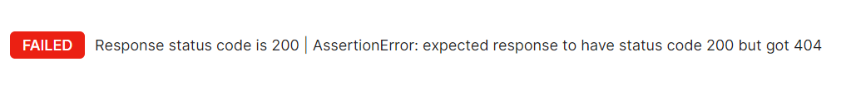

1. **Set the values for variables in Pre request script, Run the API and reset the values in Tests section**

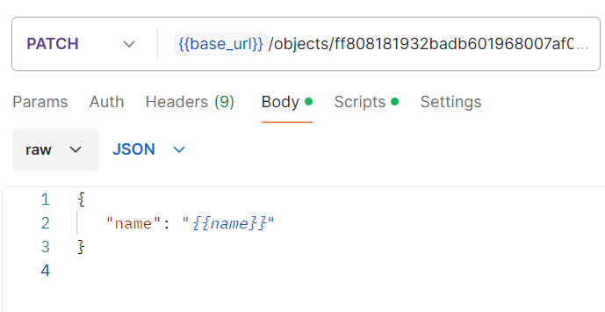

**Script:**

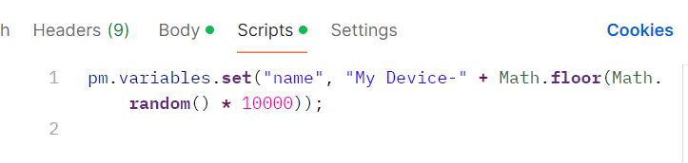

**Response Body:**

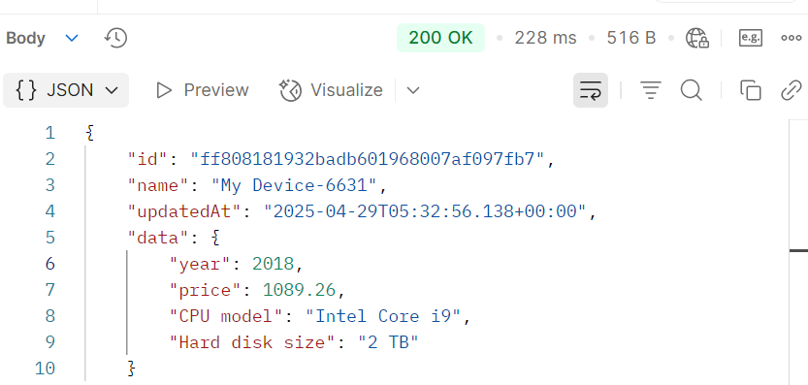

1. **Use a response from result of one API and set it as a variable. Now use the variable as a parameter in the next API. Run the two APIs as a collection. Both APIs should pass.**

**First Request (POST) — Creating a New Object**

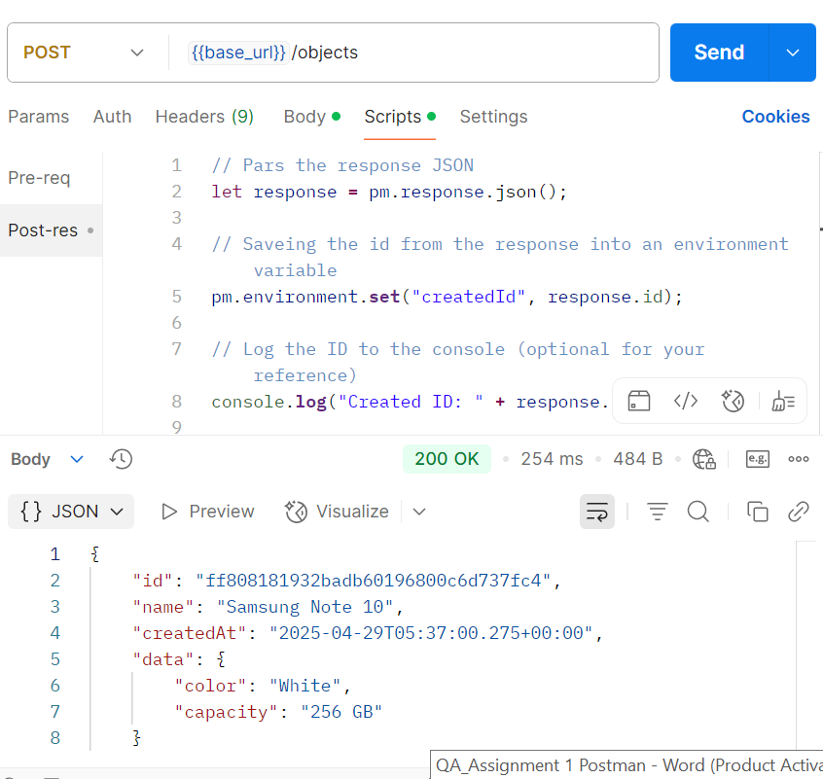

**. Second Request (GET) — Gettin Object Using Saved ID**

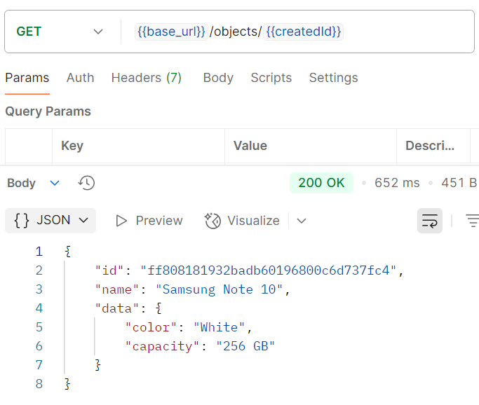

**The failed ones were intentionally failed for assignment requirements purpose:**